Warmup Task Day 1

Task1:- 3 Key Takeaway
366Pi.tech

It builds software and enterprise solutions that help businesses align digital transformation with sustainability goals.

The company works on Microsoft tools, enterprise applications, business intelligence, and future technologies for organizations.
- The company uses technology to help businesses work better while also reducing environmental impact. Their solutions improve daily operations and support eco-friendly long-term growth.

FloCard.app

FloCard is more than a digital business card — it is a sustainability ecosystem.

Users can share digital identity through QR codes, links, and app-based exchange this makes contact sharing easy, secure, and paperless.

FloCard connects business activity with environmental impact
It supports tree plantation, carbon offset initiatives, and sustainable enterprise participation.

Task 2:- Connected with 3 team member.
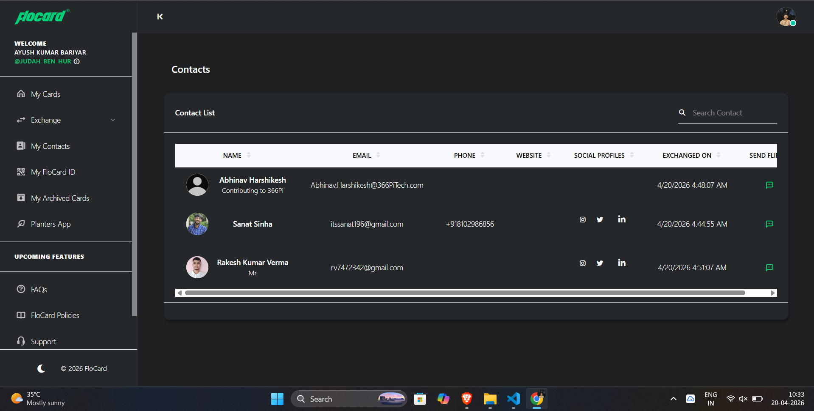

Task 3:-
Understanding the FloCard Ecosystem Flow
The FloCard ecosystem is designed around three connected participants: individuals, communities, and tree planters, each playing a unique role in creating measurable environmental and social impact.
- Individuals enter the platform as contributors, supporters, or participants. They engage by exploring sustainability initiatives, supporting causes, purchasing eco-conscious products, or contributing toward impact campaigns. Their involvement helps generate both awareness and resources for larger ecosystem goals.
- Communities act as collective drivers within the platform. They bring together groups of people with shared environmental or social interests, organize campaigns, encourage participation, and help scale local impact through coordinated action and shared responsibility.
- Tree Planters represent the execution layer of the ecosystem. They carry out plantation activities on the ground, record plantation progress, and provide updates that make environmental outcomes visible and trackable. Their work ensures that contributions from individuals and communities translate into real-world ecological impact.
Together, these three flows create a connected ecosystem where digital participation supports physical environmental action, making sustainability transparent, collaborative, and scalable.

